# Business Concept

* In the travel industry, an Excel file is often used to manage hotel bookings for a particular trip, containing stay details for all group members along with their confirmation numbers.
* Currently, the process of generating hotel vouchers for individual customers involves a team manually copying data from the Excel sheet, pasting it into a Word template, and converting it into PDF format. This method is time-consuming.
* To simplify this process, we propose a Hotel Voucher Project. Here is how it works:

1. User Login and Excel Upload:
   * + Users can log in and upload the Excel file containing the booking details.
     + The project reads the Excel file and checks for any missing fields. If any field is missing, an error message is displayed.
     + If there are no errors, the data is saved to a database.
2. Voucher Generation and Download:
   * + A list of hotel names is displayed, along with an option to download all vouchers.
     + By clicking the "Download All" option, the project generates a ZIP file containing all the vouchers in PDF format, organized by the primary person's name.
     + There is also an option to download a single PDF voucher for a primary person.

# Core Business Logic

* User upload excel file, then we read voucher details from excel and that excel file convert to data table.
* Check require filed if not found give error message of missing field.
* If all require filed found, then save data table to database with sheet name.
* Display sheet name to user for bulk voucher download in single zip.
* Also user can download single pdf of individual hotel voucher on Primary person name and confirmation number.
* Also user can download single pdf of All hotel voucher print on different page with Primary person name and confirmation number.
* User can re-download it any time up to 3 months.

# Core Technical Aspects

* Project Technology is .NET Framework 4.6.2.
* Use Identity framework for Login and Register functionality.
* Third-party used by project is Spire.Doc, Xceed.Words.NET, ExcelDataReader.
* Convert excel to datatable: HotelVoucher->Models-> VoucherExcelProcessor-> ProcessVoucherExcel
* Bulk-Insert record in database: SQLHelper Project->SQLHelper Class-> Save_DataTable.
* Generate PDF: HotelVoucher->Models-> PdfService-> GenerateVoucherPdf
* Generate Group PDF: HotelVoucher->Models-> PdfService -> GenerateVoucherPdfGroup
* How to convert excel to pdf

1. Excel to DataTable(ExcelDataReader)

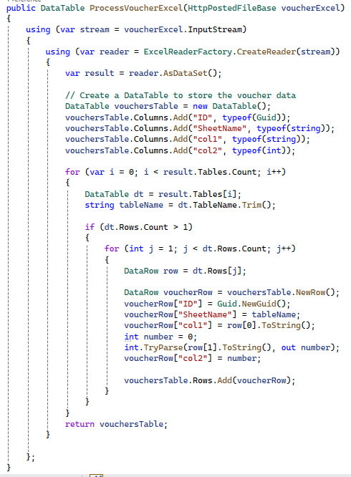

1. Save DataTable to database using bulk insert

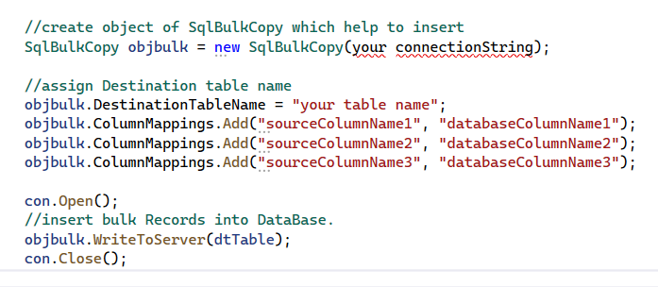

1. Set data of table in Word Template and Convert to PDF(Xceed.Words.NET, using Spire.Doc)

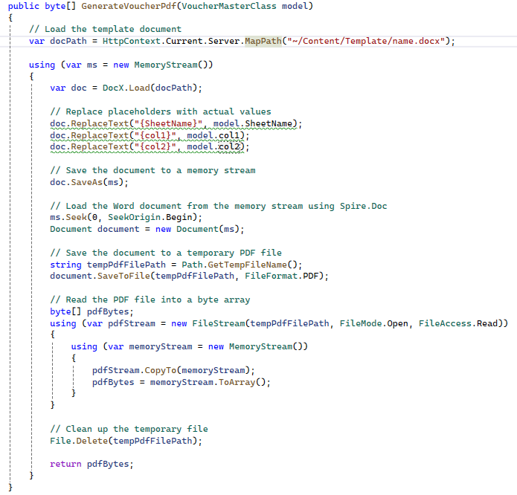

# Security Parameters

* Authorize using identity, only login user can download voucher.
* Site url is only working for vpn connect user, authenticate by google authenticator.

# Absolute To Do

* Give region to all controller method.
* Give proper naming in all project with no spelling mistake and proper spacing.
* Always use try…catch and maintain error log.
* Take backups of important files and databases before deploying to the server.

# Error Handling And QAF

* Try…catch
* Git push every day.
* Query Performance.

# Incident Book

* Non-Critical

1. Don’t show sql exception direct to user, instead show message “contact developer to solve problem”.

# Keywords

* Hotel Voucher
* Make Zip
* Generate PDF
* Word to PDF
* Excel to Data table